Report to the North Pacific Fishery Management Council
For the
Bering Sea and Aleutian Islands Management Area (BSAI) Groundfish Fishery Exempted Fishing Permit #07-02.

Karl Haflinger, Sea State Inc. - Project Manager
John Gruver, AFA Catcher Vessel Intercooperative - Project Manager and Permit Holder

Doug Christenson, Pollock Conservation Cooperative - Permit Holder

This report is to the North Pacific Fishery Management Council and covers the Bering Sea and Aleutian Islands Management Area (BSAI) Groundfish Fishery Exempted Fishing Permit #07-02. During the course of the fishery, the pollock Intercoop closed 13areas to fishing in the 2007 A season and 52 areas during the 2007 B season, based on high bycatch rates for chinook or chum salmon, experienced by vessels working in the area. Maps of the closures are shown in Appendix 1. Under the terms of the EFP, applicants are to submit to the Council a report analyzing:

- Number of salmon taken by species during the experiment
- Estimated number of salmon avoided as demonstrated by the movement of fishing effort away from salmon hot-spots.
- A list of each vessel’s number of appearances on the weekly dirty 20 lists for both salmon species
- A compliance/enforcement report that will include the results of an external audit designed to evaluate the accuracy of the approach used by Sea State to monitor compliance with the agreement, and a report on the effectiveness of enforcement measures stipulated under the ICA in cases of non-compliance. Examination of a randomly selected subset of vessel/days representing 10% of the catch during the experiment will be used as the basis of the audit.

Number of salmon taken by species during the experiment:

The EFP ran for both the entire pollock A and B seasons in 2007. For the sake of comparison we have included catch and bycatch running back to 2000. These data are compiled from plant landing information for catcher vessels delivering to shoreside processors, and observer data for mothership catcher vessels and catcher-processors. The “other salmon” category includes all non-chinook salmon. Observer data for both offshore and shoreside deliveries show that only very small numbers of salmon other than chum in this category (for example, 152 unidentified, 31 pinks, and 5 silvers for the 2006B season EFP).

Table 1. Catch and bycatch of pollock and salmon in the directed pollock fishery by season and for full years, 2000 – 2007.

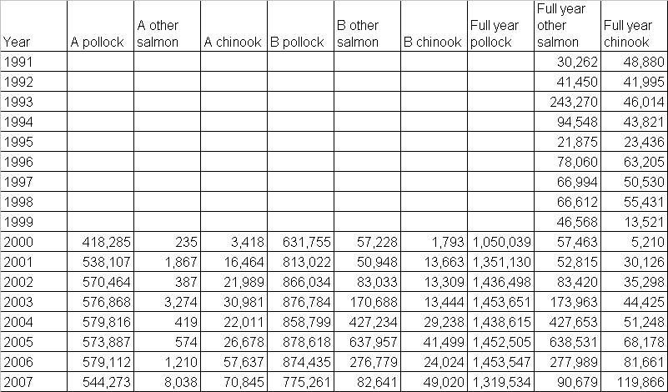
Estimates of salmon bycatch for 1991-1999 are for all groundfish fisheries, including CDQ, and are available on the NOAA Fisheries, Ak Region web site.
(http://www.fakr.noaa.gov/sustainablefisheries/catchstats.htm)
Estimates for 2000 – 2007 (compiled by Sea State, Inc) are for the pollock fishery only and were made using observer data when available and numbers of salmon counted at shore plants and reported on fish tickets for unobserved shoreside vessels.

Evaluation of salmon savings.

The evaluation of the number of salmon saved by the IC program is based on tracking vessels that fished in a closed area before it closed, and then comparing their subsequent bycatch to see if it was lower than expected if the area had not closed. Put more simply, we perform a before-and-after comparison of the bycatch observed and expected from the vessels that triggered the closure. The procedure is as follows:

- Extract all observer data for haul locations falling inside a closure area, for a 5 day period preceding the closure. For shoreside catcher vessels, aggregate the hauls that have the same “start fishing date” so that hauls with the same bycatch rate are not artificially repeated. As an example, if 2 hauls from the same catcher vessel trip show up in the closed area, they will have the same bycatch rate because observers pro-rate bycatch evenly across all hauls. Consider them a single observation with a value equal to the sum of the two hauls’ pollock and salmon.
- Consider all of independent offshore sector (C/P and mothership) hauls, and combined “trip-level” hauls to be estimates of the bycatch ratio 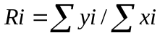, where y are counts of chinook or chum salmon, and x is the pollock catch from individual hauls (offshore sector) or grouped, same-trip hauls (shoreside), and i indicates a separate closure.
- Extract the same haul or “grouped” haul information, for the same vessels, for the next 5 days. Their associated bycatch is available from either observer or plant delivery information. Compute their expected bycatch had they been able to stay and fish inside the now-closed area, by summing the pollock catch of all vessels in this category, and multiplying this summed pollock catch by the matching bycatch ration, Ri above.
- Compute the standard error of this estimated Y (overall salmon bycatch if vessels had stayed in the area and fished with bycatch rate R) treating R as a ratio estimator (Snedecor and Cochran, Statistical Methods, 8th Edition, p 452).

The three maps below illustrate this procedure for the chinook closure of 9/22/06. Figure 1 shows the chinook closure that began on 9/22/06, and includes the locations of observed hauls taken in that area during the 5 day period preceding the closure. After the closure, vessels who had been in that closure area (i.e. those whose hauls are shown in Figure 1) either moved a small distance to the southwest, or made large moves to the northwest (Figures 2 and 3). Lower chinook rates were found in all of the new fishing areas.

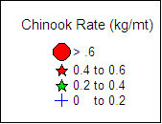

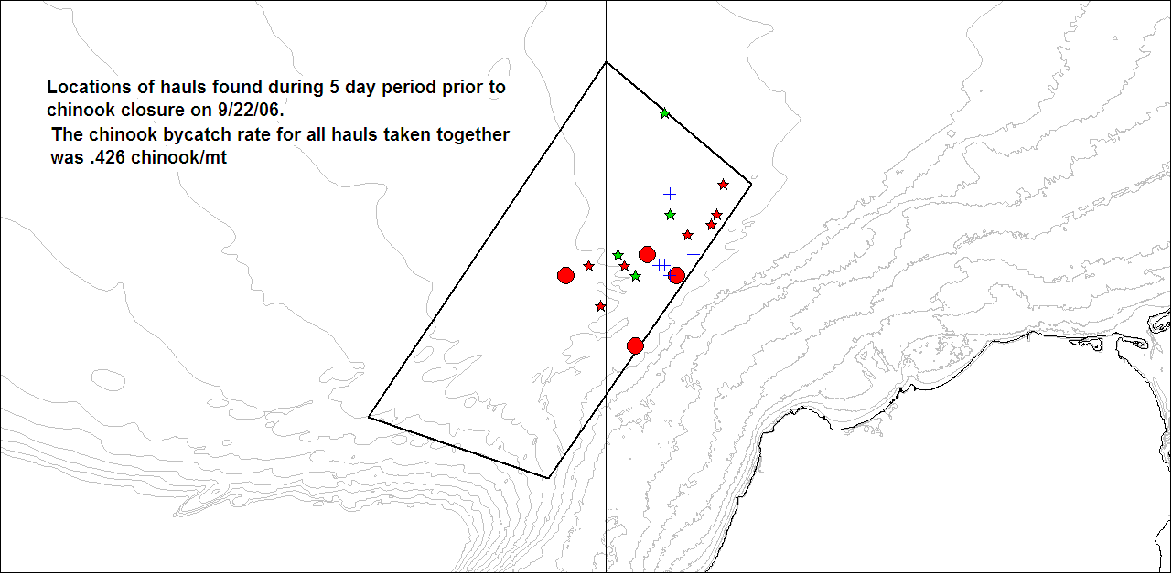
Figure 1. Hauls selected for analysis of chinook closure on 9/22

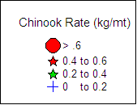
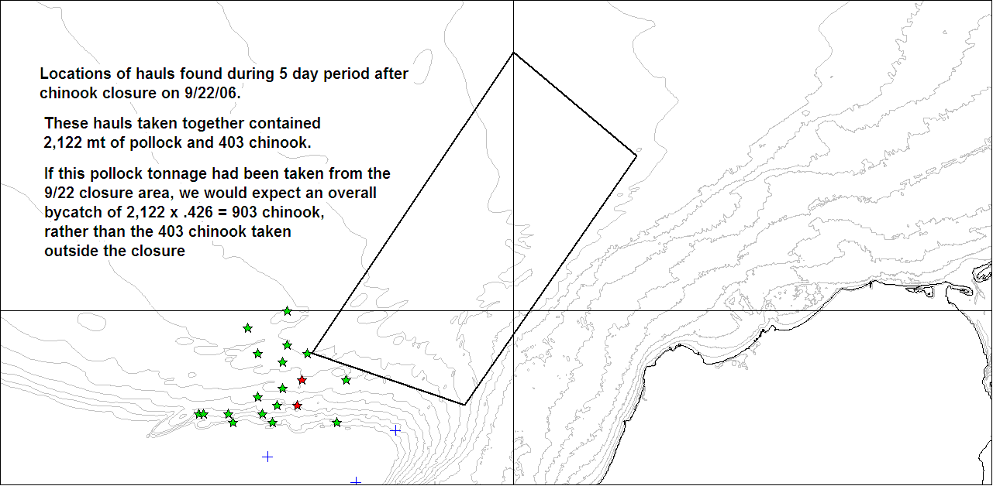
Figure 2. View at the same scale as above of five day fishing activity for vessels in the first map (Fig 2) showing positions that led to a reduction from an expected chinook take of 903 to 403 actual (i.e. counted by observers from the haul positions shown).

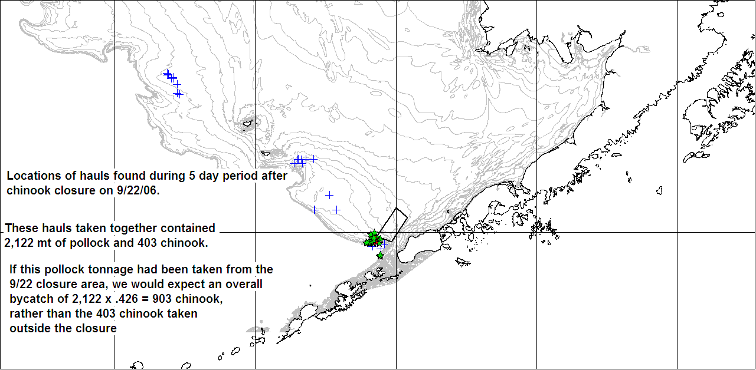
Figure 3. Full view of all hauls from boats in map 1-A for the 5 day period after the start of the 9/22 closure

Avoidance results from the 2007 EFP

The results from these calculations for the 2007 A and B seasons are shown in tables 2a and 2b below. (Charts showing the closures issued for both seasons may be found at the end of this document. Because so many closures were issued, we have not produced a chart for each closure and instead have grouped closures by season and species on three separate charts.) During the A season there were 12 closures. Of these there were 10 closures for which observer data could be found from vessels fishing inside the areas before they closed. (Note that closures may be based on deliveries from catcher vessels that did not carry observers, and thus there could be closures for which there is no observer information prior to the closure). Of these 10, all had post-closure observer information for vessels that fished inside prior to the closure (that is, we had observer information for boats both before and after the closure). Again, shoreside catcher vessels may have had an observer aboard before the closure but then delivered and come back to the grounds without an observer, thus removing the boat from before/after comparisons. Table 2a summarizes of the results for both chinook savings resulting from these closures (Appendix Tables A1a-c show the underlying data, by closure, with associated standard errors). The results indicate that for the approximately 103,000 mt of observed groundfish associated with boats that fished inside areas before they were closed, and that also had observers after closures, 35,500 chinook were avoided. This represents a reduction of 70% from the bycatch of chinook that would have been expected had the vessels continued to fish in those closure areas for another 5 days. Table 2a also shows observed and expected chum numbers, but since chum bycatch during the A season is such a small part of the overall chum bycatch for the year, these numbers are not particularly significant.

Table 2b shows results obtained in a similar fashion for the B season. 55 closures were put in place during the B season, and of these 40 closures had both pre- and post-closure observer data that allowed for an analysis of reductions. As with the A season, some closures were based on shoreside delivery information and VMS track inspection alone, leaving no pre-closure information for analysis. Post-closure information was not available for 2 periods after the 10/23/07 closure because that closure was continued forward for another week (2 closure periods) on the judgement of Sea State and the IC manager. Rates in that area were judged too high to allow more fishing, and the IC agreement allows us to keep an area closed in the absence of data. However, with no pre-closure information (since the area was already closed, no one could be fishing in it), we cannot judge the effectiveness of continuing that closure. Table 2b indicates that the combination of chinook and chum closures resulted in 182,000 mt of pollock catch that could be tracked. Chinook savings of 14,576 from an expected bycatch of 27,048 (had boats continued to fish in the closed areas) indicates a reduction of 54%. Chum savings of 86,410 from an expected chum take of 101,191 (that would have been taken had vessels continued to fish in the closed areas) indicate a reduction of 85% in expected chum bycatch.

Table 2a. Summary of 2007A Chinook closure effectiveness
 | Chinook closures
Pollock catch (after closure) | 102,592
Actual chinook bycatch (in moved tows) | 15,600
Expected chinook bycatch | 51,150
Chinook savings | 35,550
% reduction | 70%

Table 2b. Summary of 2007B chinook and chum closure effectiveness
 | Chinook closures | Chum closures | All closures
Pollock catch (after closure) | 74,465 | 107,646 | 182,111
Actual chinook bycatch (in moved tows) | 10,879 | 1593 | 12,472
Expected chinook bycatch | 23,448 | 3600 | 27,048
Chinook savings | 12,569 | 2,007 | 14,576
% reduction | 54% | 56% | 54%
Actual chum bycatch | 20,317 | 16,926 | 37,243
Expected chum bycatch | 30,757 | 92,896 | 123,653
Chum savings | 10,440 | 75,970 | 86,410
% reduction | 34% | 82% | 70%

Table 3 summarizes these documented savings for both the 2006 and 2007 EFP. We term these “documented” because they are based on a direct before-and-after comparison of the performance of vessels that triggered the closures. However, the portion of the entire pollock harvest affected by closures by not documented should not be underestimated. There are other boats whose activities are affected by closures but that do not fall into this analysis. These include vessels without observers and vessels that avoided the closure areas entirely and chose instead, in the B seasons, to fish to the northwest, where salmon are rarely encountered. For shoreside catcher vessels in particular, the uncertainty over whether or not the grounds they are fishing will be closed is significant. These catcher vessels often have only two days time in which to fill their vessels and if in the middle of a trip their grounds are taken away by a salmon closure, they may eventually be forced to return to shore with only a partial load. We cannot quantify the weight of this factor in captain’s decision to fish away from the closure areas, but have had the concern reported to us and note that it is another avenue in which salmon closures reduce bycatch, but one that cannot be analyzed with the methods at hand.

Table 3. Documented savings summary for 2006 and 2007 EFP
 | 2006B | 2007A | 2007 B
Pollock harvest moved from closures | 41,691 | 102,592 | 182,111
% of pollock harvest affected | 8% | 19% | 23%
Chinook savings | 1,537 | 35,550 | 14,576
% reduction | 20% | 70% | 54%
Chum savings | 15,419 |  | 86,410
% reduction | 67% |  | 70%

Compliance/ Enforcement

The table below shows the status of all violations forwarded to coops by Sea State during the 2006 and 2007 EFP periods. Note that at the time of preparation of the final report for the 2006B season EFP coops had not completed their final determination on violations forwarded to them; thus, the final disposition of those violations is reported here. There were twelve potential violations noted in 2006. Of those, coops determined that seven were actually not violations as vessels had been using the closed areas for turning with the trawl doors up. These determinations were based on logbook notations and vessel speeds calculated from VMS data. It was clear that there existed different interpretations of the term “fishing” as used in the Intercoop agreement, with some operators thinking that a vessel could not be considered to be fishing if trawl doors were up. This ambiguity in the term was addressed in the new Intercoop agreement, which makes it clear that vessels may not haul their doors up and then use the closure area to turn the vessel, and after turning set out again without bringing the catch onboard.

Potential violations for the 2007 EFP were less controversial. All six potential violations forwarded to coops in 2007 were determined to be true violations.

Resolution of potential violation notices send to coops for the 2006B and 2007 A and B EFP fisheries.
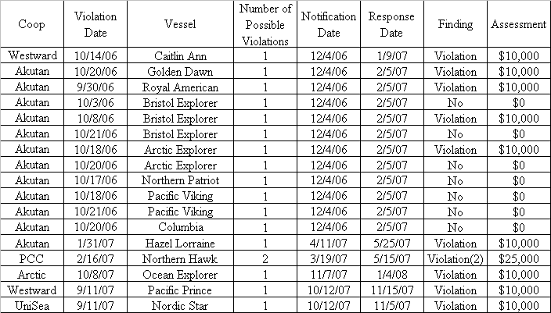

An audit of Sea State compliance monitoring was again performed by ABR Inc of Fairbanks, Alaska. ABR performed an independent review of 10% of the coop fishing records and associated VMS information, and agreed with all of Sea State’s findings for violations. ABR has also provided some very useful approaches on filtering out non-fishing operations from VMS data, and has also provided suggestions on the uses of logbook information in this process. Their report will accompany this report at the February meeting of the NPFMC.
Comments on the 2007 A and B seasons and changes to the IC closure system for 2008

Finally, Figures 4a,b and 5a,b show chinook bycatch rates for various pollock fishing areas, and contrast the 2006 and 2007 seasons (both A and B season). In Figure 5, data has been limited to October, which is when most chinook were encountered. Comparing years shows elevated chinook rates in 2007 relative to 2006 in areas near the horseshoe. Rates around the Pribilofs did not change markedly between 2006 and 2007, while rates north of the Pribilof, while still low, increased by an order of magnitude in the B season (from .013 to .12 salmon/mt). The net result is the increase in the chinook bycatch rate shown in Table 4. Shoreside and offshore sectors are shown separately only because our offshore records go back further. Both sectors have shown a similar increase in chinook bycatch rates, especially in the A season.

Table 4. Shoreside and offshore chinook rates based on data compiled by Sea State.
Sea State shoreside recording began in 2000.
Year | Shoreside A | Offshore A | Shoreside B | Offshore B
1996 |  | 0.057 |  | 0.021
1997 |  | 0.014 |  | 0.027
1998 |  | 0.042 |  | 0.032
1999 |  | 0.015 |  | 0.010
2000 | 0.006 | 0.011 | 0.010 | 0.003
2001 | 0.037 | 0.034 | 0.010 | 0.024
2002 | 0.039 | 0.036 | 0.026 | 0.007
2003 | 0.035 | 0.054 | 0.023 | 0.012
2004 | 0.047 | 0.036 | 0.064 | 0.013
2005 | 0.062 | 0.043 | 0.102 | 0.011
2006 | 0.147 | 0.071 | 0.063 | 0.004
2007 | 0.153 | 0.113 | 0.147 | 0.024

The pollock fishery encountered record levels of chinook bycatch during the 2007 seasons. CPUE’s on chinook salmon, measured simply as the number of salmon caught per hour of fishing, summed across all vessels, rose dramatically in 2006 and continued to stay at high levels throughout 2007 (Figures 6a,b and 7a,b). Slight declines in salmon CPUE were seen in the shoreside CV data, but offshore sectors saw increased salmon CPUEs. Also, any lowering in the shoreside CPUEs were cancelled by a greater decrease in pollock CPUE, leading to bycatch rates higher than any seen since the mid-1990s.

The situation with chum salmon was much different, with obviously lower levels of chum on the grounds and total bycatch for the season falling to the lowest level in five years.

Chinook bycatch in the A season contained unusually high numbers of small salmon (see figures 8a,b below). Chinook bycatch in the B season appeared to have fewer small salmon although the separate modes that appeared in the 2007A length frequencies are not so pronounced in the 2007B bycatch. These high levels of bycatch of small fish mean that we will not understand the correlation between bycatch of chinook in the Bering Sea and return to Western Alaskan drainages for several years. It may be that high bycatch levels presage very high returns, or it may alternatively mean that the distribution of chinook throughout the North Pacific and Bering Sea has somehow changed so that more of the run is vulnerable to being taken as bycatch. Regardless, it was clear to the Intercoop that our current system of closures was insufficient to meet these very high, and unanticipated, levels of salmon abundance on the pollock grounds. The Intercoop has thus taken the following steps to make the program more effective in 20008:
- The base rate for chinook in the A season will float after February 14th. It is currently adjusted on February 14th, but if bycatch levels are declining the result will be that no areas are found above the threshold for closure. Although the IC did in fact issue salmon advisories that all vessels observed, we were asked by CDQ groups and Western Alaskans to allow the base rate to float so that the program would not depend on voluntary observance of salmon advisories should this situation occur in the future.
- The area available for closure in the A season increases to 1,500 sq mi. The previous total area that could be closed for A season chinook bycatch was 1,000 sq mi.
- The area available for closure in the B season increases to 1,500 sq mi. The previous total area that could be closed for B season chinook bycatch was 1,000 sq mi.

- A predefined A season closure shown below (Figures 9 and 10) will be observed for the entire A season. The area to be closed is defined by a heavy black line in the chart below. It was determined by trying to bound the areas that show the consistently highest A season bycatch rates, but still leave fishing grounds deeper than 180 fm open. This preseason closure area appears to match the highest bycatch rate areas found by Council analysts as well (see Figure 11, slide from Council presentation below)

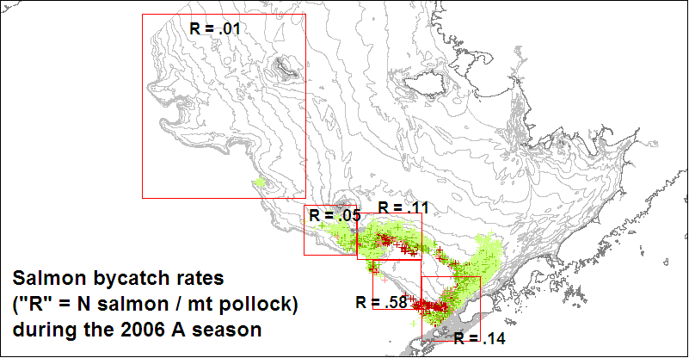

Figure 4a.

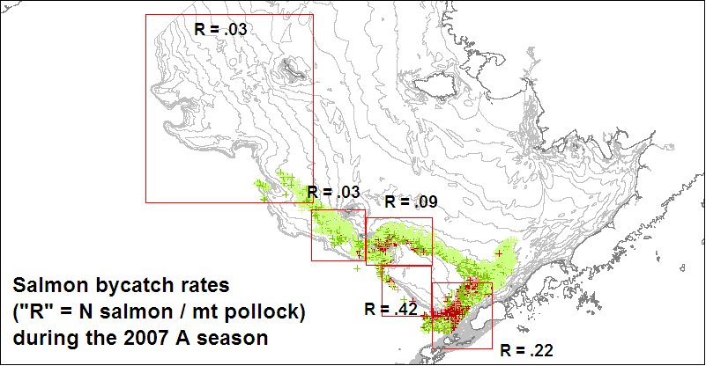

Figure 4a,b. Comparison of bycatch rates between areas fished during the 2006 and 2007 pollock A seasons. Shading indicates level of chinook bycatch, ranging from light green (lowest) to red (highest). Shading scale is the same for both years.
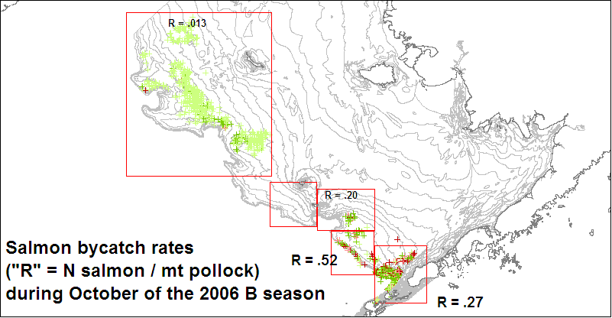

Figure 5a.

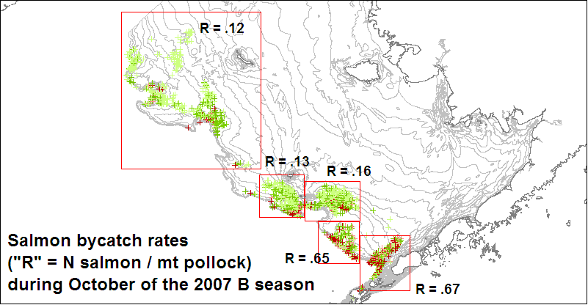
Figures 5a,b. Comparison of bycatch rates between areas fished during the 2006 and 2007 pollock B seasons. Shading indicates level of chinook bycatch, ranging from light green (lowest) to red (highest). Shading scale is the same for both

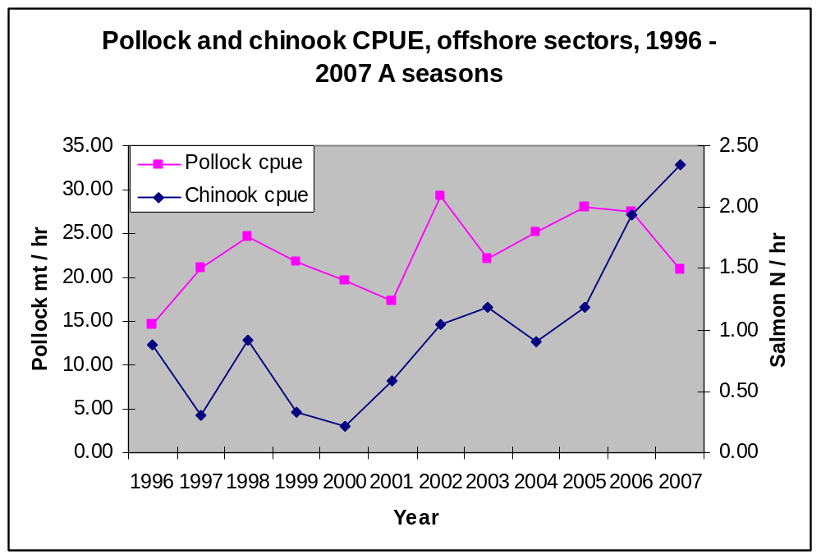

Figures 6a,b. CPUE of pollock and chinook in the 2007A season

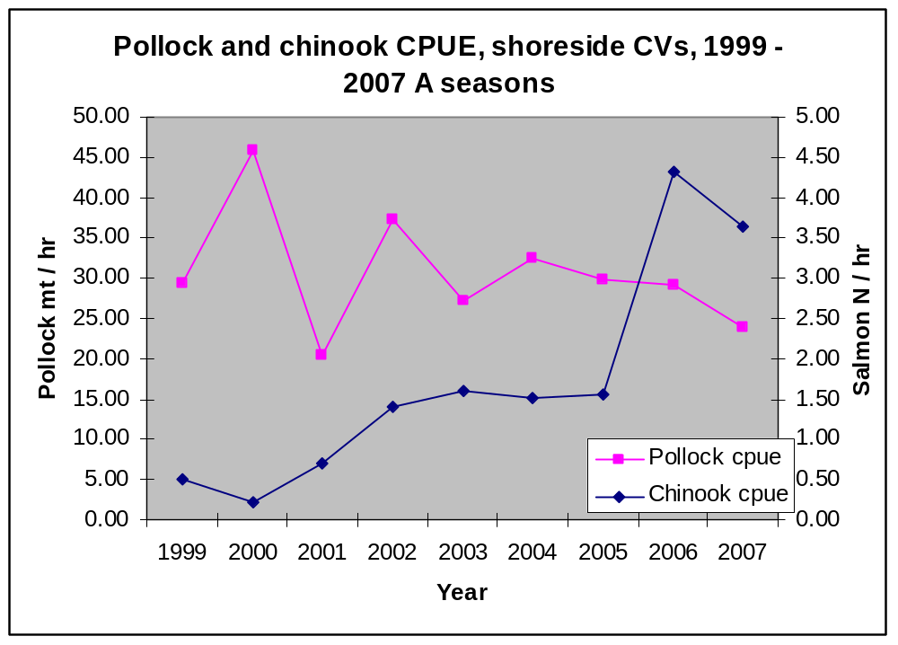

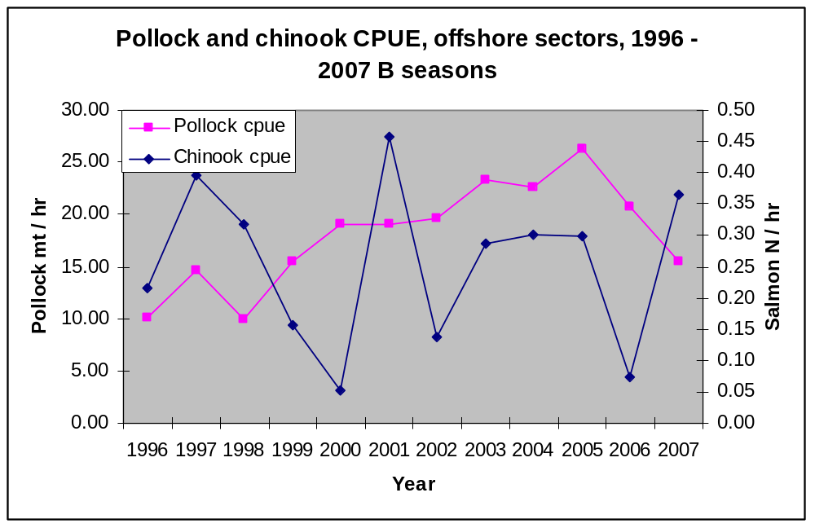

Figures 7a,b. CPUE of pollock and chinook in the 2007B season

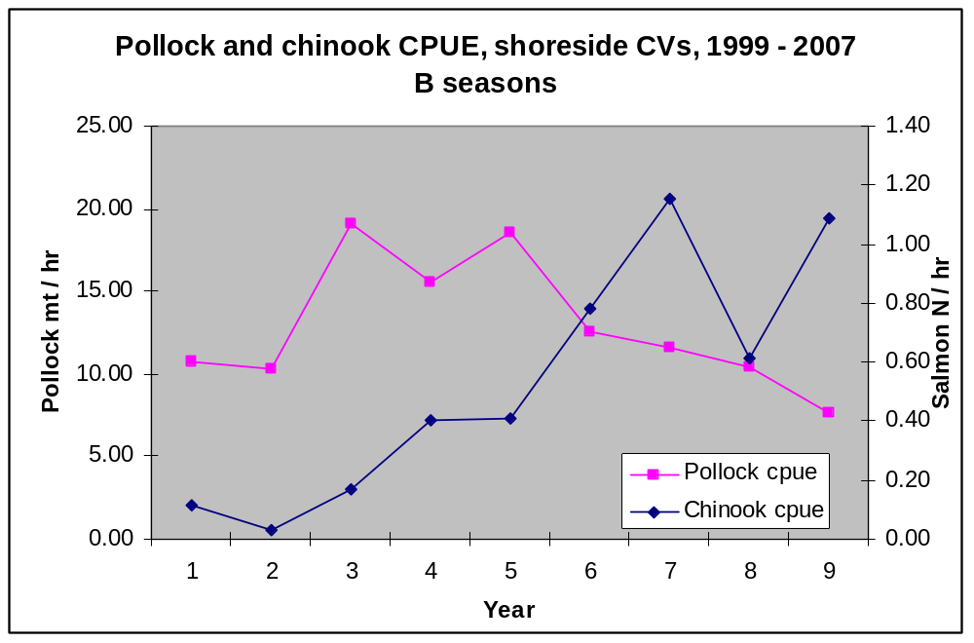

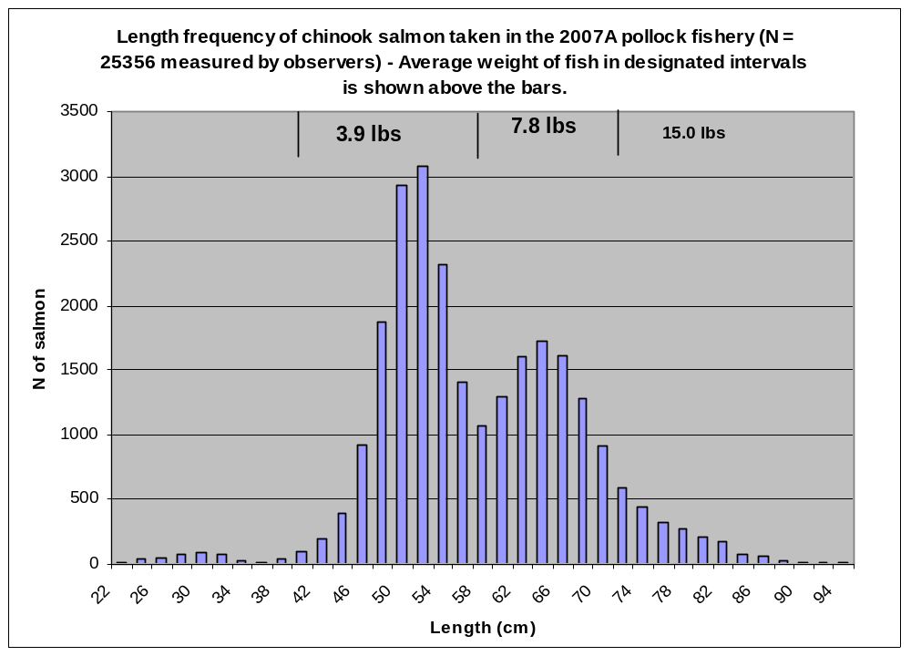

Figure 8a,b. Length frequencies of chinook, 2007A and 2007 B seasons.

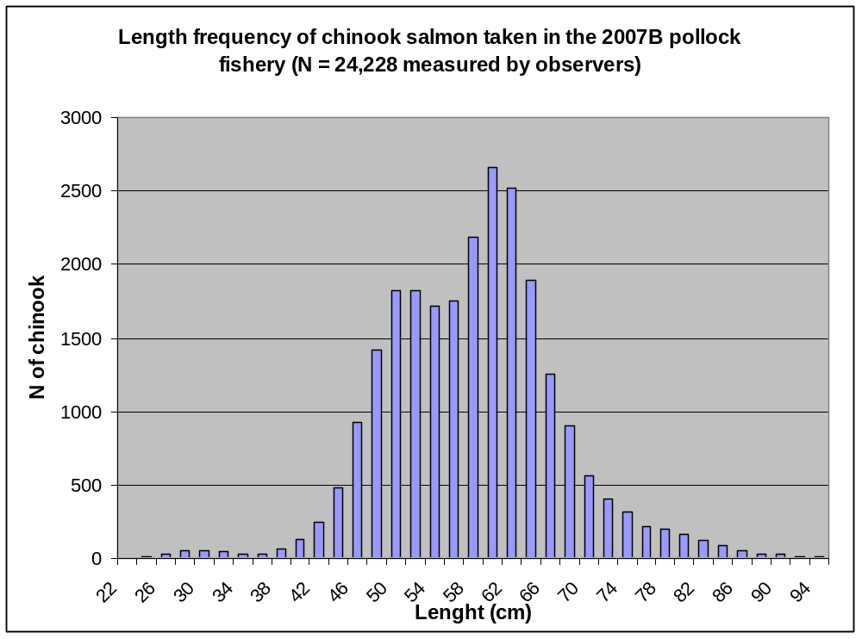

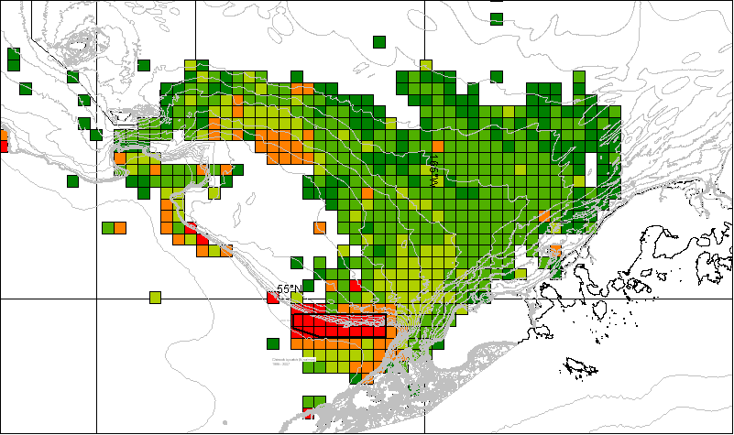
Figure 9. A season pre-season closure

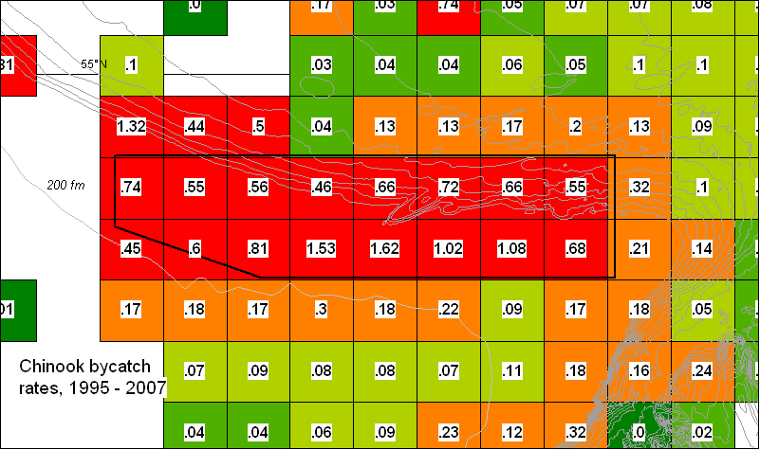
Figure 10, A season pre-season closure

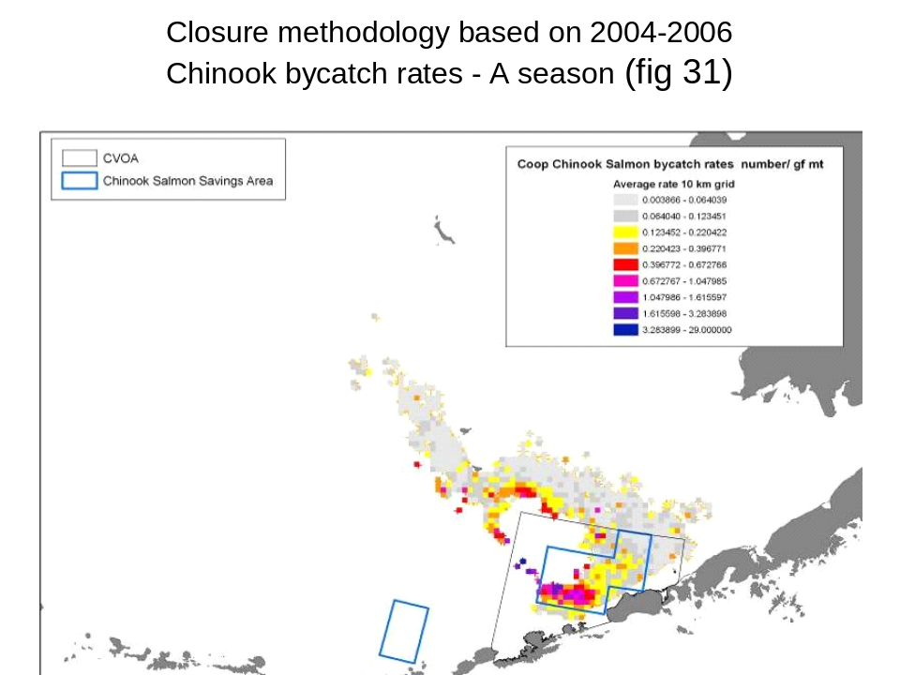

Figure 11. Correspondence between high bycatch areas noted by Council analysts and pre-season closure (above).
Appendix 1. Before-and-after closure fishing comparisons, by closure.

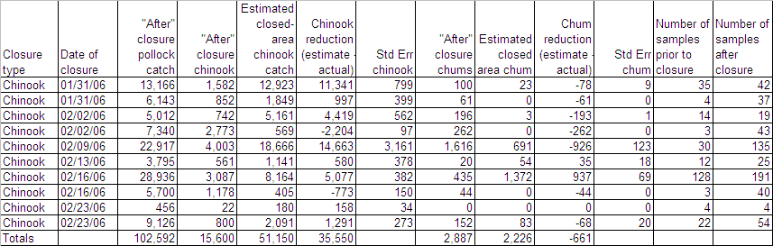
Table A1a. Chinook and chum salmon closure effectiveness, 2007 A season

Table A1b. Chinook and chum salmon closure effectiveness, 2007 B season, by chinook closure.

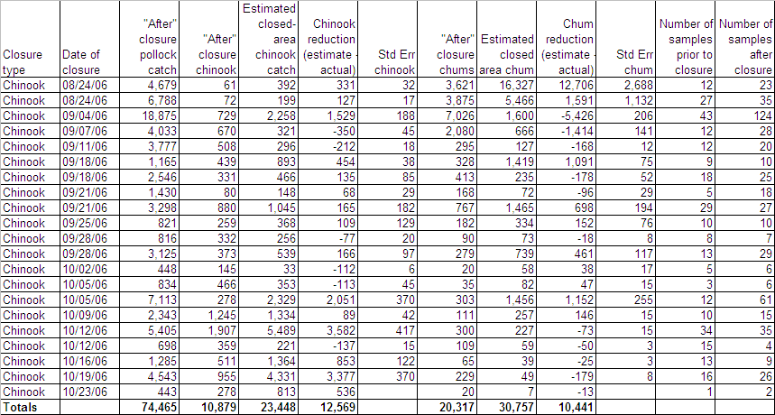

Table A1c. Chinook and chum salmon closure effectiveness, 2007 B season, by chum closure.

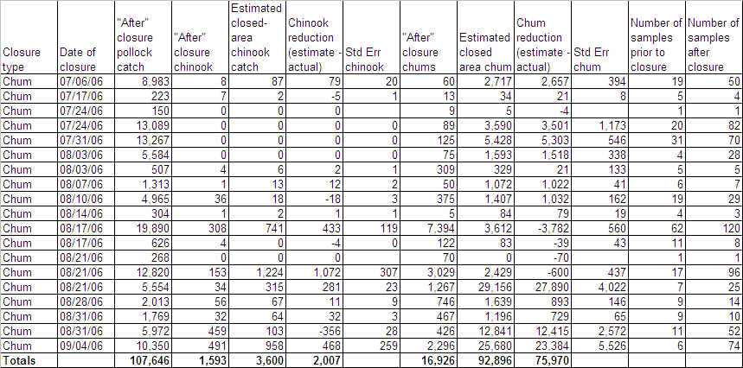

Appendix 1: Charts showing closures

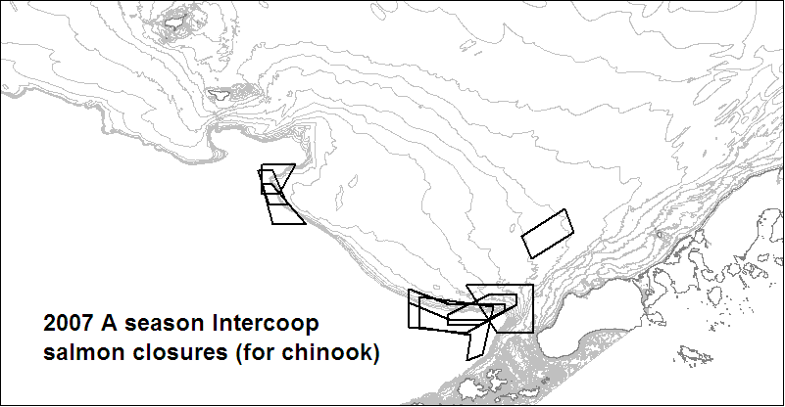

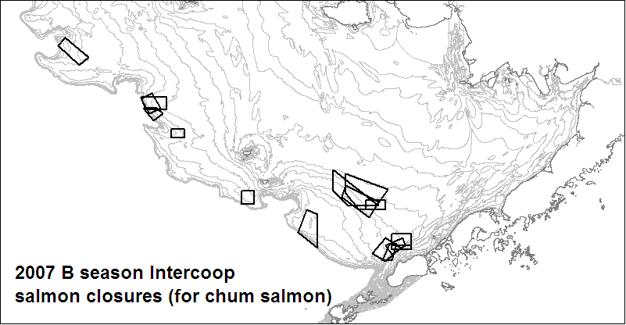
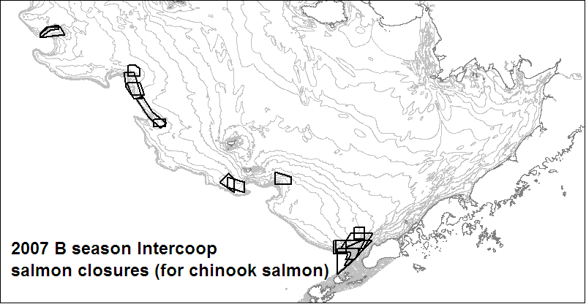

Appendix 2: Dirty 20 list appearances

Number of weeks each vessel was on the 2007 A season chinook dirty 20 list

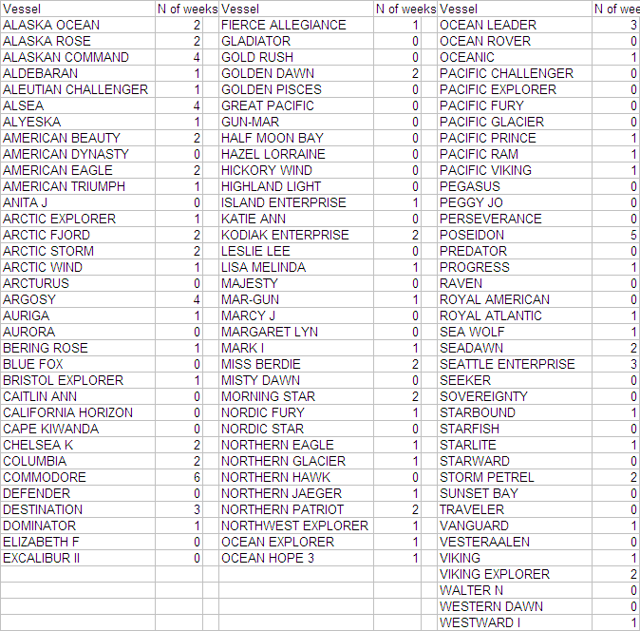
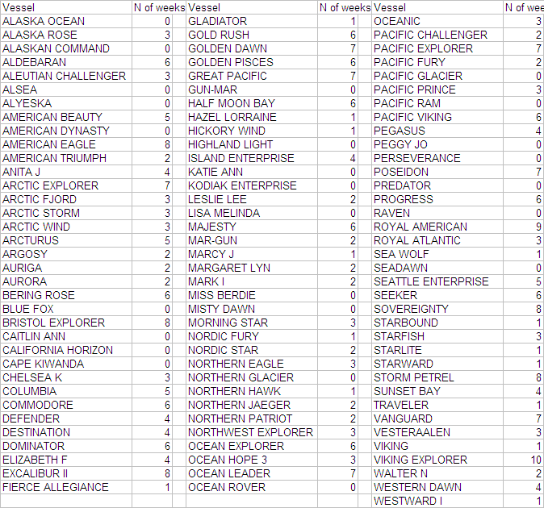
Number of weeks each vessel was on the 2007 B season chum dirty 20 list

Number of weeks each vessel was on the 2007 B season chinook dirty 20 list
